

User Manual

**Content Solutions for Your Business**

Limited

XXXXXXX

DISCLAIMER

The contents of this document are proprietary and confidential to XXXXXXXX Limited may not be disclosed in whole or in part at any time, to any third party without the prior written consent of XXXXXXX Limited.

© 2018 XXXXXX Limited. All rights reserved.

Copyright in the whole and any part on this documents belongs to XXXXXXXX Limited. This work may not be used, sold, transferred, adapted, copied or reproduced in whole or in part, in any manner or form, or in any media, without the prior written consent of XXXXXXXX Limited.

Application Release Version: 1.0.0.0

Document Version: 0.1

XXXXXXXX Limited

XXXXXX

Electronic City, Bangalore

Karnataka 560100

**Phone:** +91 9000000000  
**Fax:** +91 9000000000

**Support Email:** [support@xxxxxxxxx.com](mailto:support@xxxxxxxxx.com)  
**Sales Email:** [sales@xxxxxxxxx.com](mailto:sales@xxxxxxxxx.com)

**Website:** [www.xxxxxxxxx.com](http://www.xxxxxxxxx.com)

|  |  |  |  |  |
| --- | --- | --- | --- | --- |
| **Document Revision and Approval History** | | | | |
| **Title:** | User Manual | | | |
| **ID:** |  | | | |
| **Effective:** | XX-XX-XXXX | | | |
| **Edition No.** | **Release Date** | **Author’s Name** | **Version** | **Change Description** |
| 01. | XX-XX-XXXX | Author 1 | 0.1 | Initial Issues |
|  |  |  |  |  |
|  |  |  |  |  |
|  |  |  |  |  |

Document Revision

Contents

1 Introduction 1

1.1 Scope 1

1.2 Goal 1

1.3 Audience 1

1.4 Structure of this Guide 1

2 Logging into Confluence 2

3 Confluence Space 3

3.1 Create the Space 3

4 Create Personal Space 5

# Introduction

## Scope

This manual provides detail information about setting up and using the Atlassian Confluence application.

## Goal

This document is intended to provide information on Atlassian Confluence. Administrators/User can refer this guide to perform various administrative, operational and user level activities.

## Audience

This document is aimed at Customer Users/ Employees/ Administrators belongs to application support group and maintenance user who will be responsible for performing the various task.

## Structure of this Guide

Below table explains documents conventions used throughout this document:

|  |  |  |
| --- | --- | --- |
| **Icon** | **Title** | **Meaning** |
| Image result for caution icon for Documents png | Caution | Indicates situation that might result in loss of data or hardware/software damage |
| Related image | Tip | Indicates important features or instructions |
| Related image | Note | Additional test for important information |
|  | Bold | Bold text indicates menu name, button and field names |

# Logging into Confluence

To log into Confluence

1. Open the URL of **ATLASSIAN** in a browser windows.

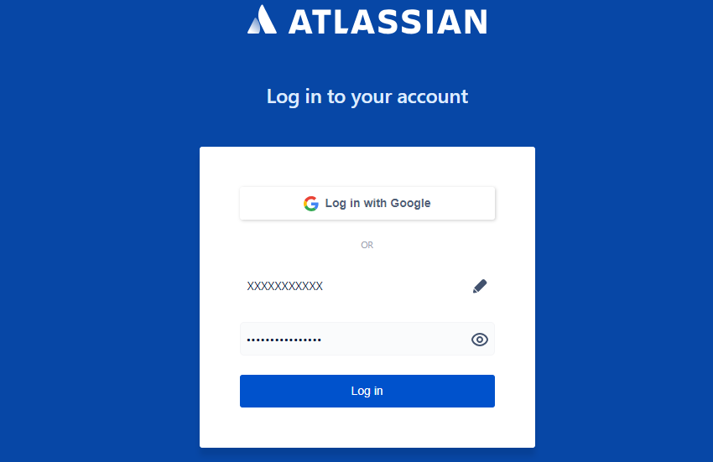

1. Enter the credentials: **Username** and **Password**.

The credentials are authenticated based on the authentication type configuration.

1. Click **Login**

On successful authentication and authorization, you will be redirected to the confluence page.

 Confluence can be accessed over Firefox (23 and above) Internet Explorer (10 and above) and Chrome (39 and above)

# Confluence Space

There is no limit to the number of space user can create on confluence. User can choose to set up a space for each project, team, or a mix of both depending on your needs.

Each space in confluence function automatically, which means that each space.

* Personal Space
* Site Space
* Set own permission or set permissions by the space admin

## Create the Space

To create space for confluence

1. Log into **ATLASSIAN** page
2. Choose **Spaces**
3. Click Create Space

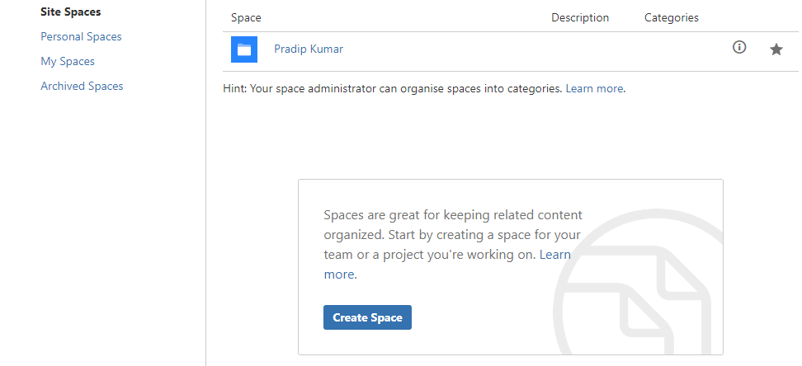

The appication will redirect to create page

1. Click **Create**

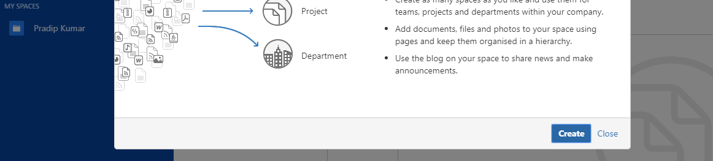

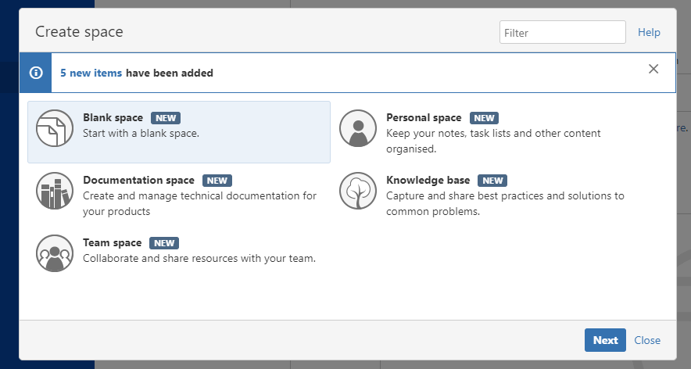

1. Select the **Blank Space** option and choose **Next**
2. Enter a Space Name and Space Key
3. Click **Create**

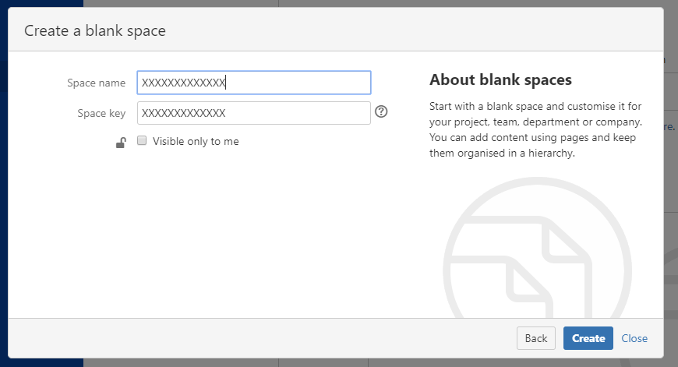

# Create Personal Space

To create personal space for confluence

1. Log into **ATLASSIAN** page
2. Choose **Spaces**
3. Click Create Space
4. Click **Create**

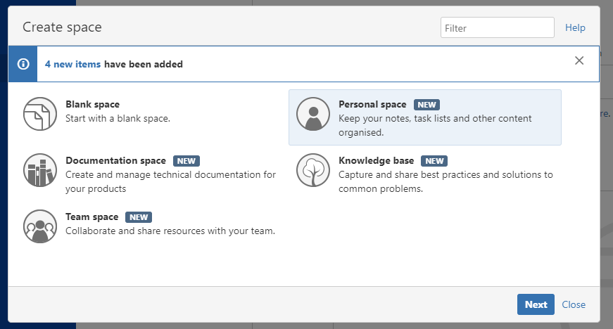

1. Select the **Personal Space** option and choose **Next**
2. Click **Create and create your personal space**

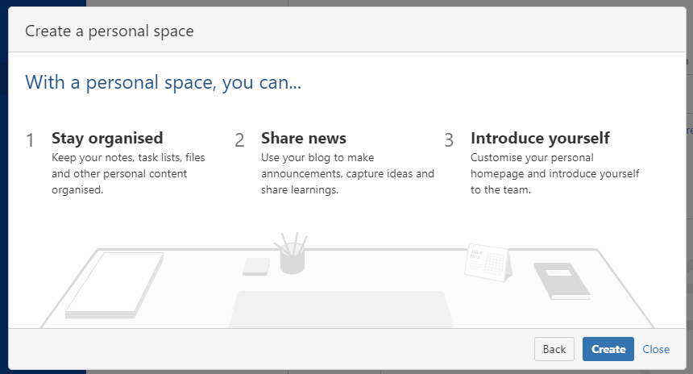

Index